Tech Watch: 15 MW+ Offshore Turbine Platforms
Sofie Lindqvist · 29 September 2026

1. Summary
Harrow Bay uses the Halden HTS-12 (12 MW, 236 m rotor). For projects reaching FID after 2028, 15 MW class turbines with 240–260 m rotors will be the market standard. This note compares what we know about the platforms and what it means for our next offshore bid.
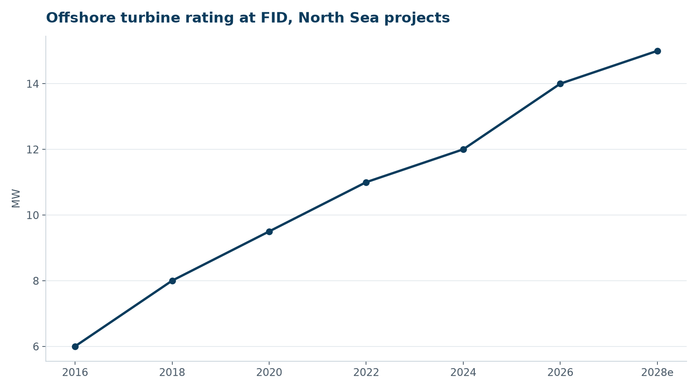
Typical turbine rating at FID for North Sea projects

2. Platform comparison (indicative)
Platform | Rating | Rotor | Drivetrain | Prototype | Serial production
Halden HTS-15 (announced) | 15 MW | 248 m | Medium-speed | 2027 | 2029
Supplier B | 15 MW | 236 m | Direct drive | Installed 2024 | 2026
Supplier C | 14–15 MW | 222 m | Direct drive | Installed 2022 | 2024
Supplier D | 16 MW | 252 m | Medium-speed | Installed 2023 | Asia only

3. Implications
- Fewer foundations: a 480 MW farm needs 32 instead of 40 positions – fewer monopiles, but each larger (10–11 m diameter).
- Installation vessels: hook heights above 170 m – the MV Sea Atlas can handle up to ~14 MW nacelles.
- Wake losses: larger rotors at the same spacing in metres increase wakes; spacing must be re-optimised in D.
- Supply chain: monopile fabrication of > 10 m diameter is concentrated at few yards, Rhenus Steelworks included.
- Reliability: serial defects in early 14–15 MW fleets (blades, main bearings) argue for strong warranties.

4. Next steps
- Meet Halden (Lars Henriksen) on HTS-15 roadmap at the Q4 supplier review.
- Update offshore cost model with 15 MW reference turbine for the Northfield bid.

